**DESIGN AN ARDUINO VISITOR COUNTER**

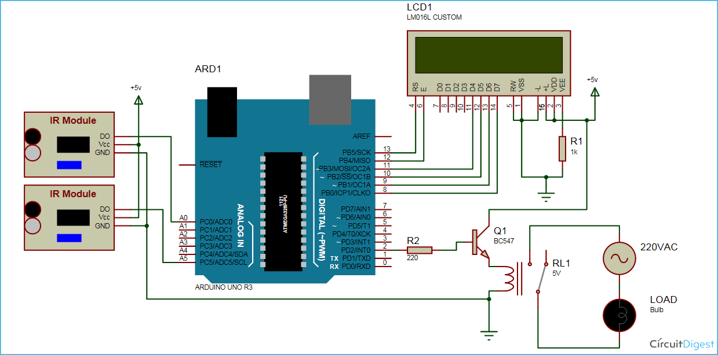

**THEORY**

**CONCEPT USED:**Bi-Directional digital visitor counter gate and automatic room light controller

**LEARNING AND OBSERVATIONS:**

1.The aim of our experiment is to make a controller based model which can sense if any person enters the room,it lights up the room automatically and also counts how many person are actually in the room.

2. It is made to prevent electric power waste in schools, colleges,offices,and houses. The whole process is operated automatically by sensors.

**PRECAUTIONS:**

1.2IR sensors should be used.

2. LCD should be used.

3. Wires should be connected properly.

**LEARNING OUTCOMES:**

The objective of the project is to make a controller based model to count number of persons in the room and display on the LCD.